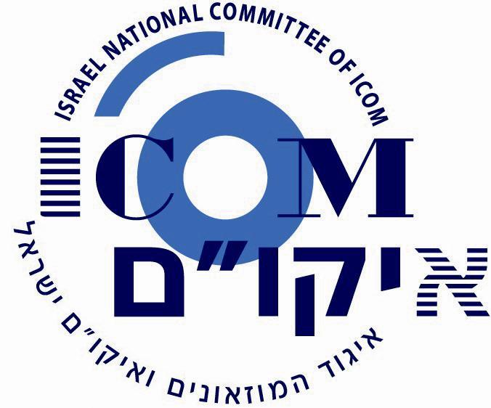
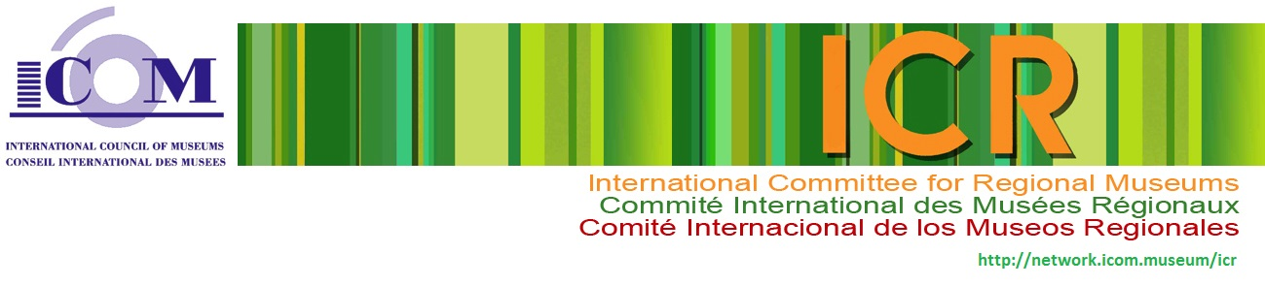

Schedule*
16.9.2015

The International Council of Museums – ICOM
The International Committee for Regional Museums – ICR
2015 Annual Conference in Israel
19–23.10.2015
Regional Museums and the Forging of Identities in a Multicultural Society

Sunday, October 18 ICR Board Meeting: all day
Venue: Begin Center, Jerusalem
Monday, October 19 Conference Meeting: all day
Venue: The Israel Museum, Jerusalem

08:00 Departure from the hotel
08:15- 9:00 Arrival at conference venue and registration
Conference moderator: Robert Kool, Israel
09:00- 9:30 Opening ceremony
James S. Snyder, Director of the Israel Museum
Dorit Wolenitz, ICOM Israel, Chair
Rune Holbek, ICOM ICR, Chair
ICR's new publications, Jean Aase, ICOM ICR, Secretary
*Program is subject to change
09:30-10:10 Keynote speaker 1: Idit Amihai, Israel
Map of the Museums of Israel: History and Meaning

10:10-10:25 Short dance performance

10:25-11:10 Keynote speaker 2: Avner de Shalit, Israel
On Milkshakes and Boxers – Inclusion in Multicultural Cities
11:10-11:30 Coffee Break

11:30-13:30 Session 1; Moderator: Rune Holbek, Norway
Kenji Saotome, Japan
Forging Identities of Regional Society under Multi-dimensional Value Systems- Securing Museum Accessibilities and Participations of People with Visual Impairment
Birendra Mahoto, Nepal
Regional Museums and the Forging of Identities in a Multicultural Society: The case of the Narayanihiti Palace National Museum of Nepal
Liang Min & Li Zhan, China
Regional Museums and the Forging of Cultural Identity for the Juvenile
Otto Lohr, Germany
What role do regional museums play in the process of changing to a multicultural society in Bavaria?
Asaf Ron, Israel
The Intercultural city of Haifa – overview and challenges
Blanca Gonsalez, Mexico
Museums and identities

13:30-15:30 Lunch break and guided tour at the museum

15:30-16:45 Session 2; Moderator: Nava Kessler, Israel
Vardit Shotten Hallel, Israel
The Kingdom of the Knights in the Hospitaller Compound at Acre, Israel
Shaked Shamir, Australia
Australian Design Centre: Visitors' engagement with touring design
Exhibitions
Marge Rennit, Estonia
Museum’s ambition to influence a district’s image: The case of the Tartu City Museum
Zeljko Andelkovic & Ivan Mitic, Serbia
Museums and Reconciliation
Said abu Shakra, Israel
Art as a Tool for Social Change in a Multicultural Society

16:45-17:15 Coffee Break

17:15-18:45 Session 3; Moderator: Helmut Sydow, Germany
Tuulia Tuomi, Finland
The multicultural programs and activities of the Regional Museums in Finland - are there any?
Eldad Shaaltiel, Israel
Bridging the gap - Arabs and Jews meet at the Israel Museum, Jerusalem
Anna Nadolska - Styczynska, Poland
To recognize oneself while learning about others: Activities of the Municipal Museum in Zory for the dissemination of knowledge regarding cultural diversity of the world
No'am Bar'am - Ben Yossef, Israel
The Inter Dialogue manifested in over covering of religious Jewish, Muslim and Christian women in Israel

19:00 End of Day 1

Tuesday, October 20
Venue: Joe Alon Center, The Museum of Bedouin Culture

07:30 Departure from the hotel
09:00 Arrival and registration
Conference moderator: Robert Kool, Israel
09:30 Opening ceremony

10:00-10:30 Keynote speaker 1: Gornaka Horjan, Croatia
Social Relevance of Regional Museums in the 21st Century

10:30-11:15 Session 1; Moderator: Irena Zmuc, Slovenia
Havazelet Yahel, Israel; Noam Perry, USA; Ruth Kark, Israel; Shelly Shenhav, Israel
Multiculturalism and Ethnographic Museums in Israel: The Case of a Regional Bedouin Museum
Laura Evans & Joni Acuff, USA
Museums as Change Agents: Examples of Multiculturalism in Practice
Tirza Lavi, Israel
Preserving Identities – Cultural Heritage Center – The Cochin Jews of India

11:15-11:30 Coffee Break

11:30-12:00 Keynote speaker 2: Rafik Halabi, Israel
The Druze Society in Transition

12:00-13:15 Session 2; Moderator: Carrie-Ann Lunde, Canada
Anamery Bagenyi, Tanzania
Regional museums and the Forging of Identity in Multicultural Societies
Metka Fujs, Slovenia
Museum – Community – Development, or how to understand common heritage in a multicultural environment
Eddie Wei-Chun Lai, Taiwan
The impacts of a small local museum development for the Southern Branch of the National Palace Museum
Nina Rodin, Israel
To what Extent does a History Museum’s Collection Represent the Identity of its Locality?

13:15-14:45 Lunch break and guided tour at the museum

14:45-16:00 Session 3; Moderator: Noga Raved, Israel
Sladana Velendecic, Serbia
Living together, an exhibition about the Serbs and Hungarians in Vojvodina
Tal Zor, Israel
Memory and creativity promote social change in the multicultural city of Jerusalem
Azucena Suarez de Miguel, Mexico
El Cocinero Mexicano (1831), A Cookbook Memory of the World
Idit Sharoni, Israel
Embroidery of life: Embroidery as an expression of social and cultural transformation

16:00-16:15 Coffee Break

16:15-18:00 Session 4; Moderator: Revital Duvdevani, Israel
Kago Tswiio, Tanzania
Museums and the forging of identities in a multicultural society
Song Xian & Hu Fang, China
Museum exhibition technology revolution for modern audience
Wang Xiaoming, China
How regional museums form a museum cluster and forge its identity
Bracha Slae & Ora Pikel Tzabari, Israel
Bridging time and space in Old Jerusalem
Yeala Hazut, Israel
The role of cultural Institutions in the Intercultural City – the case study of Museum without Walls

18:00-18:15 Summary: Jean Aase, Norway

18:30 End of Day 2

